Keeping Cool when those around you are losing their heads

Well the weather is still unbelievable for those arriving here from the UK for their summer break, compared to the bleak rainy weather they are having back home. This is the time of year when our pools are made good use of and also require the most attention, not only keeping them clean but also in being kept topped up. This week I have had two clients raising concerns about their pools.

The first client has recently had their pool constructed by a specialist pool company, and whilst I had a few reservations on the way it was being built in the end with some compromise on the part of my client it does not look too bad, although I am told the water has never cleared properly since it was finished. This is a common problem, usually as a result of the contractor not cleaning the pool properly prior to filling, resulting in the surplus grout used on the tiling staying in suspension and not being effectively removed by the filter as the grout particles are too small to be filtered away. My client’s pool looked like a weak potato soup for many weeks as a result of this. Eventually regular cleaning and vacuuming went a long way to overcome the problem but it never gained the crystal clear clarity they were hoping for. I was asked if I had any ideas as they were becoming despondent with the pool maintenance company. I asked my friend who has attended proper pool cleaning and maintenance courses in the UK if she could help.

It did not take long to establish the problem. The pool was not being maintained properly, the pH was high and the chlorine was non-existent - a recipe for disaster. My client could not understand how the chlorine was low as when swimming earlier there was a distinct smell of chlorine and the family’s eyes stung whilst swimming. Ah I thought, this is something to do with combined chlorine. We rely upon chlorine to keep our pool water sanitised but it is the free chlorine that does the work. Things haven’t changed much in that regard since I was a child in the mid 50’s, I remember going along to the municipal baths with the school and learning to swim, and coming out with stinging eyes. I always thought the cause of stinging eyes was from the chlorine itself, but I have since learnt that it is caused by nitrogen trichloride, this is a heavy irritant chlorine smelling gas produced as a result of chlorine combining with ammonia [combined chlorine]. It lies on the water and attacks the bathers’ eyes and can cause breathing difficulties as well. This can be a problem when pH levels are wrong. The principal reason for adding chlorine to pool water is to destroy potentially harmful micro-organisms. In reacting with the organisms some chlorine is itself destroyed but the amount lost is very small compared to the amount added. Chlorine is also a powerful oxidising agent and much of the polluting matter introduced to the pool water by bathers is capable of oxidation. Most of the loss of chlorine is due to such oxidation, and as a result this loss must continually be replenished to ensure there is a residual level of chlorine in the pool to deal with fresh pollution. Another factor in the use of chlorination as a disinfectant is the importance of monitoring the pH value of the water to ensure that it stays somewhere between 7 and 8. Where there is a pH value of 7 the chlorine disinfection is nearly 70% effective, but at a point where the water has a pH value of 8 then the chlorine disinfection is less than 20% effective. This is what was happening the chlorine was not an effective oxidising agent due to the high pH and was forming a combined chlorine, relatively inefficient and an irritant.

So what do we learn from this? In previous articles I have stressed the importance of regular maintenance, which includes the proper physical cleaning of the pool, although with some pool maintenance companies this often leaves a lot to be desired. The pool should not only be vacuumed, the pool edges and walls need to be regularly brushed or scoured clean to remove any harmful algae, also the overflow channel should be cleaned regularly. You can then do your own checks see how thorough their cleaning process has been. When it comes to the chemical balance of the pool, unless you have the right testing equipment and know how and when to use it, you must take on trust that the pool company are getting this right, although I sometimes have big doubts on this having frequently seen chemicals just being thrown into pools. It is all about balance – if the chemicals are not used correctly so that a proper balance is maintained then they are effectively useless as they were in my client’s pool, however some shock treatment of the pool soon brought things under control.

This time of year, one of the most important things to remember is to get a pre-swim shower as this will remove up to two thirds of the sweat products and one third of the bacteria that would otherwise end up in the pool. It also keeps out of the pool the dreaded suntan lotion which will soon make pool walls go green. Remember if pre-swim showers were always the norm then pool water would be cleaner, easier to disinfect using fewer chemicals and be more pleasant to swim in.

My second client rang me in desperation from the U.K. saying she had heard from her builder that her new pool was in a ‘dangerous condition’, supposedly dirty and at a very low level which would damage the pumps. Strange I thought, I saw no problem when I looked in earlier in the week. Well on further investigation it appears the builder was upset that his friend was not commissioned to look after the pool and thought he would stir up some anxieties with the new owners of the house now back in the U.K. He had already tampered with the valves, putting it on overflow whereas the pool maintenance company had put it on main drain so as to conserve water as the pool was unused, so we thought. It has now come to light that the builder’s operatives living in the newly completed house next door wanted to use the pool and had the balance tank filled expecting to charge my clients for the water, which they refused. Mysteriously the balance tank was drained via the backwash and the pool water level reduced. This is the same old builder who was difficult during the construction and I have now realised he knows as little about pools as he did about roof construction! I wish he would concentrate his efforts on doing the outstanding snagging works and not winding up my clients in the U.K. So if you are not using your overflow pool put it on main drain, evaporation will be less and the requirement for top ups will be reduced.

Many thanks to Sue at TOPBRAND Pool Maintenance for her advice and sharing her knowledge Tel 0533 876 0382.

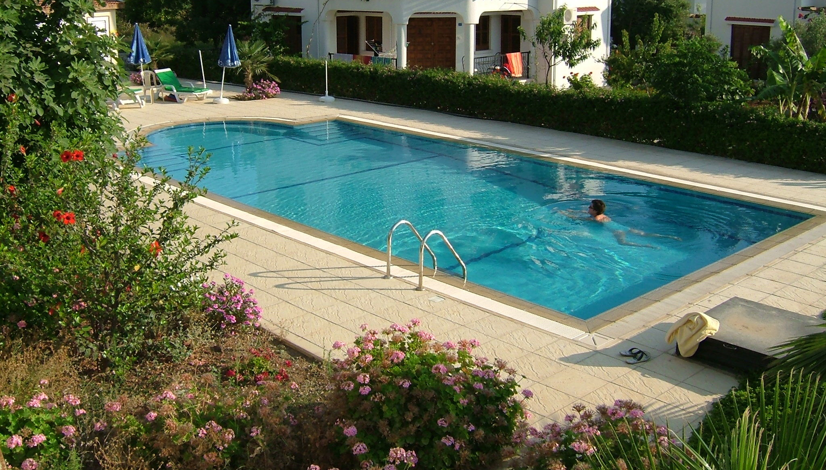

The best place to be in this weather so long as it is well maintained
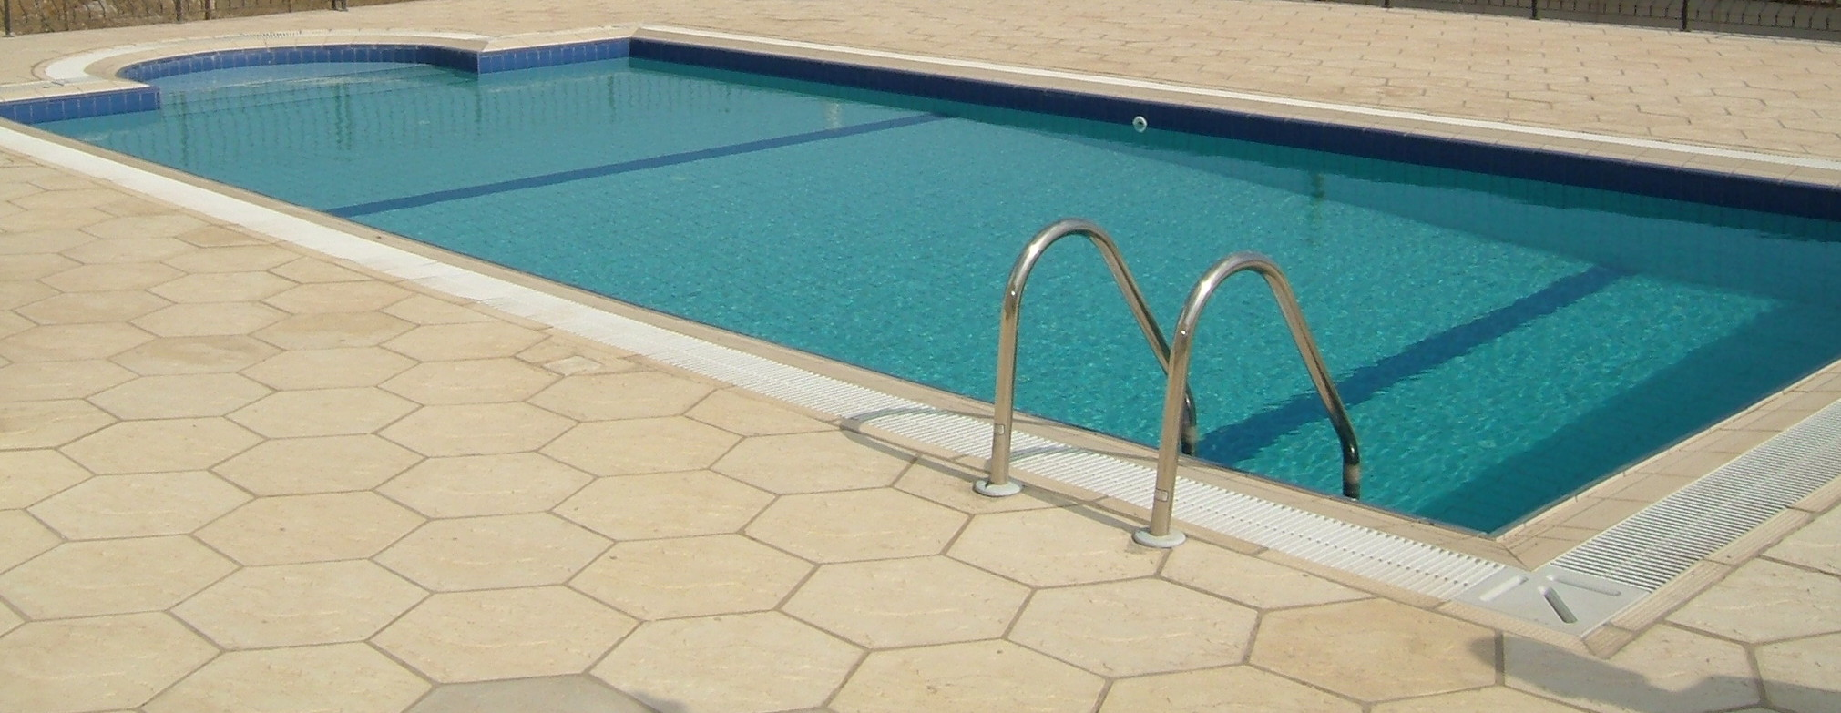
Nothing wrong with this pool on main drain

