Don’t be a drip! Part II

I wrote last week about ways of saving water through the repair of leaks, fitting of efficient valves etc. and thinking about how we use the mains water supply to us, so we use it more efficiently. Well what else can we do to save water? There are two additional ways to help in saving this precious resource, firstly – to re-use some of the water from things like washing machines, showers and wash hand basins, this is known as ‘grey water’, and secondly – to harvest the rainfall to make use of it rather than let it run away.

Well how can we use ‘grey water’? Well I am told it is good enough for the watering of your plants without having to worry too much about its contents. I won’t say it’s capable for use as drinking but in some parts of the world, domestic installations are now being introduced to clean up this water for re-use. Well how can we simply do this here? Sadly it is not so simple here as many of our waste plumbing systems are hidden beneath the floor or within the wall structures, and discharge into the same pipework as the septic waste from the toilet. If you are one of the lucky ones, where waste water from the bath/shower, wash basins and washing machine can be easily isolated, this could be diverted away from the drainage system and stored for the watering of plants etc. If we are really keen I suppose if we can’t do this, we could stand in a large bowl while showering to save the water! When we were invited to stay at the home of a friend in a remote part of Turkey, this is exactly what we did do although they didn’t have a shower facility! the water was then used for garden irrigation.

Apparently the average household uses 150 litres a day and you will see from the pie chart that only approximately 65 litres of that 150 needs to be of drinking water quality. So in the future we are going to have to give serious consideration to re-using or harvesting as alternative forms of water supply. I am pleased to say that some new developments here have modern sanitation systems installed and the treated water is being redistributed throughout these developments as suitable for garden irrigation. 46 litres of that 150 litres is used for flushing the toilet, so that immediately gets discharged into the septic tank so if it is eventually being redistributed this is a lot of water. But it also means that there is in the region of 100 litres of water which could effectively be re-used without any sophisticated treatments if used on the garden etc. The pie chart also shows that approximately half the amount of water used every day by the average household does not have to be of drinking water quality. So are we wasting the precious resource of drinking water? And should we be looking at ways to re-use water and to save rainwater which could be put to good use? This is something that will have to be looked at in the very near future if water is going to be in as short a supply as we are told.

Well in the winter months when it does rain here we just watch the water gush away and this is put to little use. Well how about harvesting this water? It sounds sophisticated but it is relatively simple, that’s of course if you have rainwater guttering and downpipes – another sore point of mine as few of us do! You can introduce a diverter/strainer into the downpipe and store water in a water butt. I believe the average rainfall here is between 400 – 500 milimetres per annum. Assuming the footprint of an average villa here is 50 square metres there could be a run off of 18 cubic metres, which could be collected/stored for use during the year. This equates to 120 days water supply for an average household! Of course there will be some evaporation, but with prudent siting out of direct sunlight I am sure much could be saved and used. This water could be simply used for garden irrigation or better still, with a more sophisticated plumbing installation, could be used for flushing the toilet and I am told as it is relatively soft water it could be used for washing! You may say ‘that’s a waste of time’ with the climate we have here, but I can remember seeing traditional homes in the Caribbean where the whole of the underside of the property, equivalent to the size of the cellar, was used for the storage of rainwater for domestic use during the long, hot, dry summers.

Well this is what we can do domestically, but there is still more that can be done here on this island. I was with an academic from one of the Universities here whose PhD paper was on the effective use of rainwater here and presently only approximately 8% of the rainfall is effectively stored for use. He tells me if we could only improve this to say 12% many of our water shortage problems could be resolved. If this is the case let’s hope some more investment is done here and between us we can all do our bit to this end.

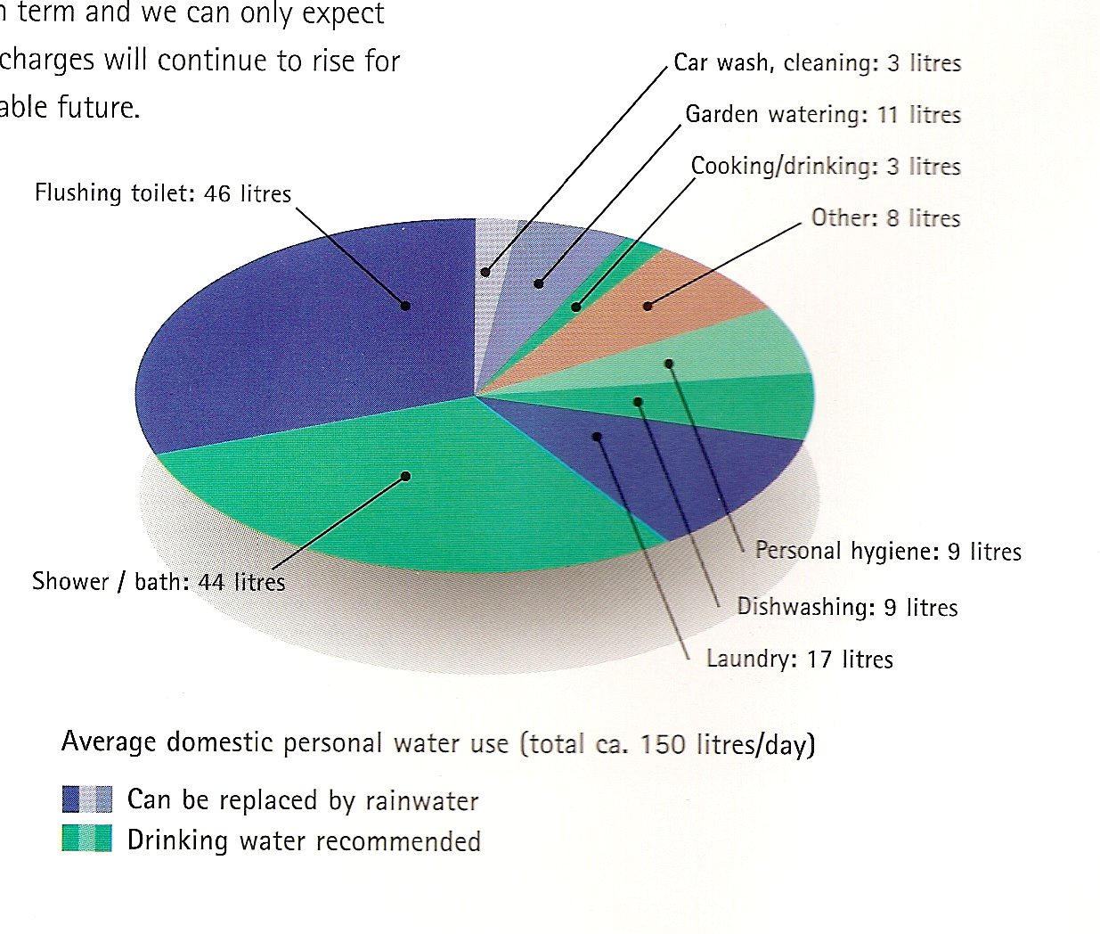

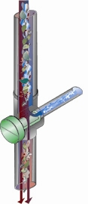
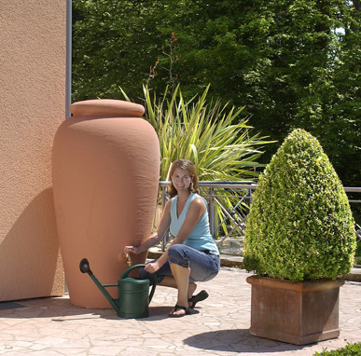
Water storage tanks don’t have to be ugly
Diagram of leaf and debris strainer for downpipes – if you have any!

